AUDIOVISUAL (AV) DESIGN STANDARDS
Academic, Administrative, Auxiliary and Residential Spaces

Prepared by Academic Technology & Outreach – December 2023

TABLE OF CONTENTS
- REVISION NOTES ........................................................................................................................... 6
2.0 PURPOSE AND SCOPE .................................................................................................................... 6
2.1 Introduction...............................................................................................................................6
3.0 DEFINITIONS .................................................................................................................................. 7
4.0 COMPLIANCE AND REFERENCES .................................................................................................... 8
4.1 Industry Standards, Guidelines and Best Practices....................................................................8
5.0 TYPES OF ACADEMIC SPACES ......................................................................................................... 8
5.1 Formal .......................................................................................................................................8
5.2 Informal.....................................................................................................................................9
6.0 TYPES OF CONFERENCING SPACES ............................................................................................... 10
6.1 Defined....................................................................................................................................10
7.0 TYPES OF CAMPUS TV SPACES ......................................................................................................11
7.1 Restrictions .............................................................................................................................11
8.0 TYPES OF DIGITAL SIGNAGE ......................................................................................................... 11
8.1 Defined....................................................................................................................................11
9.0 PHYSICAL REQUIREMENTS FOR AUDIOVISUAL (AV) SYSTEMS ........................................................ 11
9.1 Equipment Racks......................................................................................................................11
9.1.1 Design and Assembly ............................................................................................................11
9.1.2 Mounting...............................................................................................................................12
9.1.3 Cable Management...............................................................................................................12
9.1.4 Rack Cleaning .......................................................................................................................12
9.2 Lecterns/podiums....................................................................................................................13
9.3 Ventilation................................................................................................................................13
9.4 Room Layout............................................................................................................................13
9.5 Projection Surfaces ..................................................................................................................14
9.5.1 Single and Dual Screen Projection .........................................................................................14
9.6 Display Devices.........................................................................................................................16
9.6.1 Multimedia Projectors...........................................................................................................16
9.6.2 Multimedia Projection Ceiling Mount...................................................................................16
9.6.3 Flat Panel Displays.................................................................................................................17
9.6.4 Flat Panel Display Mounts.....................................................................................................17
9.6.5 Interactive Displays...............................................................................................................17
9.6.6 Campus TV Displays...............................................................................................................17
9.6.7 Digital Signage.......................................................................................................................17
9.6.8 Maximum Viewing Distance for Displays...............................................................................18
9.7 AV Control and Switching .........................................................................................................19
9.7.1 Controls and Switches...........................................................................................................19
9.8 Audio and Video.......................................................................................................................19
9.8.1 Audio.....................................................................................................................................19
9.8.2 Video ....................................................................................................................................19
9.9 Source Equipment....................................................................................................................20
9.10 Video Conferencing................................................................................................................20
9.11 Lighting...................................................................................................................................20
9.12 Lecture Capture......................................................................................................................21
9.13 External AV Input Plates.........................................................................................................21
9.14 Electrical.................................................................................................................................21
10.0 NETWORK INFRASTRUCTURE COMPONENTS AND SECURITY ...................................................... 22
10.1 Requirements.........................................................................................................................22
11.0 AUDIOVISUAL CABLING INSTALLATIONS .................................................................................... 22
12.0 ADA COMPLIANCE AND INTEGRATION........................................................................................ 22
12.1 Hearing Augmentation...........................................................................................................22
12.2 Mounting Heights for Visually Interactive Devices................................................................22
13.0 SYSTEM PROGRAMMING .......................................................................................................... 23
13.1 Extron.....................................................................................................................................23
14.0 AUDIOVISUAL (AV) SYSTEM INSTALLATION PROCESS.................................................................. 23
14.1 General Guidelines.................................................................................................................23
14.2 Project Responsibilities by Phase............................................................................................24
15.0 RECOMMENDED HARDWARE LIST .............................................................................................. 26
15.1 Equipment Make and Model .................................................................................................26

1.0 REVISION NOTES
Revision history
Version | Change Description | Date | By
1 | Draft Document | 12/20/2022 | JA
2 | Draft Design balanced with AVIXA Standard | 02/03/2023 | JA
3 | Draft Balances against UIT wiring Standards | 08/15/2023 | CT
4 | Final Revisions and Formatting | 12/8/23 | JA

2.0 PURPOSE AND SCOPE

2.1 INTRODUCTION
This publication ensures that all audiovisual (AV) for Montana State University (MSU) spaces are designed and constructed to the standards set by Academic Technology and Outreach (ATO) and University Information Technology (UIT).
Use these guidelines as the AV standards for renovations and new construction projects to promote consistent learning spaces that effectively meet the needs of faculty, staff, and students.
This document covers the basic physical requirements for audiovisual equipment used in academic, administrative, auxiliary, and residential spaces. This document is not intended to cover all types of spaces or scenarios on campus. If these standards cannot be met, consultation with ATO and UIT is mandatory before soliciting AV design services and implementing construction work.
The Instructional Classroom Support Center updates this document periodically as functional needs and technology evolve. Each updated edition includes its effective date on the cover and in the page footers. The current version and earlier editions are available on the ATO website at:
ato.montana.edu
To ensure that all current installation standards are followed, all contractors and outside Information Technology (IT) consultants must receive approval for their design documents from the University UIT Network Service Group (UIT-NSG) before submitting them for execution. The Contractor must meet with the assigned UIT-NSG Project Manager before beginning installation.

3.0 DEFINITIONS
• ADA - The Americans with Disabilities Act prohibits discrimination against people with disabilities in several areas, including employment, transportation, public accommodations, communications, and access to state and local government programs and services.
• ANSI (American National Standards Institute) - The American National Standards Institute (ANSI) is a private, not-for-profit organization dedicated to supporting the U.S. voluntary standards and conformity assessment system and strengthening its impact domestically and internationally.
• Audiovisual Integrator - Any person or company commissioned to perform work on audiovisual systems who is not ATO Classroom Technology staff.
• AV Systems - Audiovisual Systems include all equipment necessary to fulfill the intent of communicating audio and/or video content to an audience.
• AV/IT - Audiovisual Information Technology.
• AVIXA - A trade association representing the professional audiovisual and information communication industries worldwide.
• Campus TV - A cost recovery service that provides additional pay TV channels to faculty and staff for offices, conference rooms, lobbies, lounges, and common areas throughout campus.
• DSP - Digital Sound Processor, a microprocessor dedicated to receiving the signal from the source and then routing it to an amplifier.
• HDMI - High-Definition Multimedia Interface, a proprietary audio/video interface for transmitting uncompressed video data and compressed or uncompressed digital audio data from an HDMI-compliant source device, such as a display controller, to a compatible computer monitor, video projector, digital television, or digital audio device.
- InfoComm - Former name of AVIXA before 2017; still seen in some publication references.
• NFPA (National Fire Protection Association) - The National Fire Protection Association is an international nonprofit organization devoted to eliminating death, injury, property, and economic loss due to fire, electrical, and related hazards. (National Fire and Electrical Code)
• POE - Power over Ethernet technology allows network cables to carry electrical power.
• Pro: Idiom - Encryption technology developed by LG for use in hospitality TV solutions to securely deliver high-definition digital television and video-on-demand (VOD) signals.
• Rack (cabinet, enclosure) - A frame or enclosure with mounting rails to house AV equipment.
• RU - Rack unit which, as defined in IEC 60297-3-100: 1 rack unit = 44.45 mm (1.75 inch) height.
• ITSC – Instructional Technology Support Center, Classroom Technology departmental staff.
• UIT UC (Unified Communication) - University Information Technology, Technology Services and Support, Network Services, Unified Communications.

4.0 COMPLIANCE AND REFERENCES

4.1 INDUSTRY STANDARDS, GUIDELINES AND BEST PRACTICES
Authority | Title | Document Number
AVIXA | AV/IT Infrastructure Guidelines for Higher Education | None
AVIXA | AV Implementation Handbook (to be used with ANSI/INFOCOMM 2M-2010) | None
AVIXA | Cable Labeling for Audiovisual Systems | F501.01:2015
AVIXA | Audio Coverage Uniformity in Listener Areas | A102.01:2017
AVIXA | Standard Guide for Audiovisual Design and Coordination Processes | D401.01:201X
AVIXA | Projected Image System Contrast Ratio | V201.01:201X
AVIXA | Audiovisual Systems Energy Management | S601.01:201X
AVIXA | Display Image Size for 2D Content in Audiovisual Systems | V202.01:2016
AVIXA | Rack Building for Audiovisual Systems | F502.01:2018
USDOJ | 2010 ADA Standards for Accessible Design | None

1) AVIXA™ and InfoComm International® are a trademark and a registered trademark, respectively, of AVIXA, Inc., also known as Audiovisual and Integrated Experience Association.
2) United States Department of Justice

5.0 TYPES OF ACADEMIC SPACES

5.1 FORMAL
• General Classroom, movable furniture: a flat-floored academic space with a capacity of 24-90 students, with movable furniture for flexibility of use. Suitable for many purposes, it is the most common type of classroom. Basic standard technologies include PC, projector(s), projector screen(s), control, audio, and wall/floor plate for multimedia cables (HDMI, Power, Network).
• General Classroom, fixed furniture: a flat-floored academic space with a capacity of 24-90 students, with fixed tables and/or seating. Various table layouts are employed to suit diverse types of use. Basic standard technologies include PC, projector(s), projector screen(s), control, audio, and wall/floor plate for multimedia cables (HDMI, Power, Network).

• Computer Classroom, fixed furniture: a flat-floored academic space with a capacity of 24-90 students, fixed tables and/or seating, and computers installed for each seating space. Basic standard technologies include PC, projector(s), projector screen(s), control, audio, and wall/floor plate for multimedia cables (HDMI, Power, Network).
• Seminar Room: a flat-floored academic space for small-section courses with a capacity of fewer than 24 students. Most suitable for small-group discussion and highly interactive material. Basic standard technologies include PC/input device, projector(s) and screen(s) or display(s), control, audio, and wall/floor plate for multimedia cables (HDMI, Power, Network).
• Lecture Hall: a tiered or sloped academic space with a capacity of 30-200 students. Most suitable for traditional lectures, multimedia presentations, basic distance learning, and demonstrations. Lecture Hall standard technologies include PC, projector(s), projector screen(s), control, audio, wall/floor plate for multimedia cables (HDMI, Power, Network), wireless screencasting, and video conferencing technologies.
• Auditorium: a tiered academic space with a capacity that exceeds 200 students. Most suitable for traditional lectures, multimedia presentations, distance learning, and demonstrations. Auditorium standard technologies to include PC, projector(s), projector screen(s), control, audio, wall/floor plate for multimedia cables (HDMI, Power, Network), wireless screencasting, and video conferencing technologies.
• Active Learning Classroom (ALC): a flexible, grouped-seating academic space that includes an elevated level of technology. This room type is designed to maximize student interaction and engagement. The basic standard technologies for an Active Learning Classroom include PC/input device(s), projector(s) and screen(s) or display(s), control, audio, collaborative technologies, wireless screencasting, and connectivity for multimedia cables (HDMI, Power, Network) at each seating group.
• Distance Learning Classroom: a remote or hybrid learning environment with video conferencing technology, dual stream capture, and cloud-based technological innovation. The basic distance learning classroom will include PC/input device(s), projector(s) and screen(s) or display(s), control, audio, collaborative technologies, wireless screencasting, and video conferencing technology.

5.2 INFORMAL
• Huddle/Study Room: a small conference area for collaboration with the option to include audio, video, and display system technology. Student groups often use this type of academic space.
• Conference Room: an academic space equipped with video conferencing functionalities. Each conference room can vary in size and configuration, with requirements determined case-by-case.

6.0 TYPES OF CONFERENCING SPACES

6.1 DEFINED
• Focus Room: a small room seating one to four people; may be fixed or with movable furniture for flexibility. Suitable for bring-your-own-device (BYOD), small group collaboration, or individual use. The minimum audiovisual is a noninteractive single TV (45-inch to 55-inch), HDMI for external sources, power, and Wi-Fi coverage. The room may be equipped with a USB camera, microphone, speaker (all-in-one), fixed PC, and wired network connection.
• Huddle Room: a small room seating no more than five people with fixed furniture for consistency of use. Suitable for small group meetings, video conferencing, and collaboration. Minimum audiovisual is interactive/noninteractive single TV (45-inch to 55-inch), HDMI for external sources, power, fixed PC, USB camera, microphone, speaker (all-in-one) and wired network connection.
• Medium Room: a room seating ten to twelve people with fixed furniture for consistency of use. Suitable for medium group meetings, video conferencing, and collaboration. Minimum audiovisual is interactive/noninteractive single TV (65-inch to 75-inch), HDMI for external sources, power, fixed PC, USB camera, microphone, speaker (all-in-one or wall/cart mounted), and wired network connection. Additional hardware may be a table or display hub to control the audiovisual equipment and to connect to meetings with OneTouch capabilities.
• Large Room: a room seating more than twelve people but no more than sixteen people. Suitable for large group meetings, video conferencing, and collaboration. Minimum audiovisual is interactive/noninteractive single TV (85-inch to 110-inch), HDMI for external sources, power, fixed PC, USB camera, two microphone pods/ceiling tile, two to four speakers (tabletop or ceiling configuration) and wired network connection. Additional hardware may be a table, display hub, or wall control panel to control the audiovisual equipment and to connect to meetings with one-touch capabilities.
• Boardroom: a room seating more than sixteen people. Suitable for executive meetings for large group presentations, meetings, video conferencing, and collaboration. Minimum audiovisual is interactive/noninteractive multiple TVs, HDMI for external sources, power, fixed PC, USB camera, two microphone pods/ceiling tile, two to four speakers (tabletop or ceiling configuration), and wired network connection. Additional hardware may be a table, display hub, or wall control panel to control the audiovisual equipment and to connect to meetings with one-touch capabilities.

7.0 TYPES OF CAMPUS TV SPACES

7.1 RESTRICTIONS
Spaces like offices, conference rooms, lobbies, lounges, break rooms, and public spaces can house digital signage. Spaces like dorms, private events that charge admission, establishments that sell alcohol, and sporting event venues cannot house digital signage.

8.0 TYPES OF DIGITAL SIGNAGE

8.1 DEFINED
• High-traffic areas with short view time opportunities (transitory spaces where audiences will not stop to watch), including hallways, entryways, and elevators.
• Low/high-traffic areas with long-view time opportunities, including lounges and dining areas.
• High-traffic area with short view time opportunities AND includes lounge areas with long view time opportunities, including lounge areas and waiting rooms.
• Restricted time windows for signage content, including classrooms, conference, or study rooms.
- Low/high-traffic areas where needed, including interactive kiosks.

9.0 PHYSICAL REQUIREMENTS FOR AUDIOVISUAL (AV) SYSTEMS

9.1 EQUIPMENT RACKS

9.1.1 DESIGN AND ASSEMBLY
Rack design must allow for a maximum of only 75% fill to accommodate future growth. All racks should be enclosed. Racks installed in cabinetry should have rear access in the form of a lockable door. Assemble all racks per the manufacturer’s guidelines/instructions for assembly.
In some cases, accessories such as doors and side panels will be installed and checked for proper fit but then temporarily removed to aid in the rack’s subsequent loading/populating and cabling.
Once all rack parts and accessories are fully assembled, make final adjustments before the loading/populating of AV equipment. This includes the final adjustment and location for the front, mid, and rear rack rails and all vertically mounted accessories, such as vertical cable management.

9.1.2 MOUNTING
All mounting will adhere to serviceability, electrical interference, cable, and thermal management requirements as part of the design decisions documented before the rack building. Fixing/fastening AV equipment to one another is not acceptable unless specified by the manufacturer. Fully tighten all fixings/fasteners. The use of fastening methods relying on adhesives is not acceptable.

9.1.3 CABLE MANAGEMENT
Elements of proper cable management include cable handling, serviceability, and signal separation. Pay careful attention to the placement and support of individual cables and cable looms in horizontal and vertical space.

9.1.3.1 Recommended Signal Separation
Signal Type | Common Level(s) | Audio Microphone Level | Audio Line Level | Video Cable | Data Twisted Pair Cable | RF Coax Cable | Speaker Cable | AC Power Cable
Audio Microphone Level | -60 dBV (0.001 volt to -40 dBV (0.010 volt) | No spacing requirement | Separate bundles | Separate bundles | 100 mm  (~4 in) minimum | 100 mm  (~4 in) minimum | 100 mm  (~4 in) minimum | 300 mm  (~12 in) minimum
Audio Line Level | 0 dBV (1.000 volt) | Separate bundles | No spacing requirement | Separate bundles | Separate bundles | 50 mm  (~2 in) minimum | 50 mm  (~2 in) minimum | 100 mm  (~4 in) minimum
Video Cable | 0.8 volts | Separate bundles | Separate bundles | No spacing requirement | Separate bundles | 50 mm  (~2 in) minimum | 50 mm  (~2 in) minimum | 50 mm  (~2 in) minimum
Data Twisted Pair Cable | Max 125 VDC, 30 watts (add signal level) | 100 mm  (~4 in) minimum | Separate bundles | Separate bundles | No spacing requirement | Separate bundles | Separate bundles | 50 mm  (~2 in) minimum
RF Coax Cable | 0dBmv to 50 dBmv | 100 mm  (~4 in) minimum | 50 mm  (~2 in) minimum | 50 mm  (~2 in) minimum | Separate bundles | No spacing requirement | Separate bundles | 50 mm  (~2 in) minimum
Speaker Cable | 1 watt to 1,000 watts, max 100 VRMS | 100 mm  (~4 in) minimum | 50 mm  (~2 in) minimum | 50 mm  (~2 in) minimum | Separate bundles | Separate bundles | No spacing requirement | 50 mm  (~2 in) minimum
AC Power Cable | 120/240 volts 50/60 Hz | 300 mm  (~12 in) minimum | 50 mm  (~2 in) minimum | 50 mm  (~2 in) minimum | 50 mm  (~2 in) minimum | 50 mm  (~2 in) minimum | 50 mm  (~2 in) minimum | No spacing requirement
Source: AVIXA F502.01:2018
Refer to the UIT Network Infrastructure Design Standards for additional details.

9.1.4 RACK CLEANING
At the completion of the building process, clean the rack to remove all dirt, dust, and debris. Remove all temporary labeling, ties, and tape. Remove stray wire pieces, cable offcuts, tie cutoffs, and other debris.

9.2 LECTERNS/PODIUMS
Mount audiovisual equipment within the lectern/podium assembly with specifications determined during the design consultation process.
Specialty academic spaces may require a mobile lectern/podium. If AV equipment is not housed in the lectern/podium, mount it separately with wireless capabilities within the system.
Include a lockable, enclosed cabinet section and an open-fronted cabinet section on all lectern/podium designs. Key any lockable sections to restrict unauthorized access. Open sections will be accessible for users’ AV equipment. Physical or electronic security will be present.
A connectivity panel with HDMI, USB, and power outlets will be on or near the lectern/podium. Route cables for the device connections through the lectern/podium. Cable management is necessary when the connections are running under the carpet. Provide all power and network outlets inside the lectern/podium cable cubby if possible. The cable path should be adequate in capacity to allow all signal cables and future expansion.
Determine final lectern designs during the design consultation process. The audiovisual integrator will provide external audiovisual connections for BYOD devices such as laptops, which will retract and be hidden away when not required.

9.3 VENTILATION
All AV equipment generates heat. Regardless of location, adequate ventilation (airflow) must be required to prevent unacceptable temperature rise. Cooling and ventilation characteristics will vary according to the AV equipment. The AV integrator will determine the thermal units in a system to provide the best cooling system.
All racks and lecterns/podiums require airflow vents. Mechanical devices that contain moving parts, such as fans, located in or near the lectern should have minimum noise to eliminate distractions in the academic space.

9.4 ROOM LAYOUT
The space dimensions and orientation affect the AV design. Careful placement of AV equipment is necessary to ensure ADA requirements are met.
Room layouts will be considered in consultation with ITSC during the design process.
See AVIXA, AV/IT Infrastructure Guidelines for Higher Education recommendations regarding sightlines, viewing angles, image heights, and other critical room design considerations.

9.5 PROJECTION SURFACES

9.5.1 SINGLE AND DUAL SCREEN PROJECTION
Center motorized data projection screen(s) in the room for uninterrupted viewing from each angle and, if possible, recess in the ceiling. Position the screen(s) one (1) foot away from the wall or whiteboard, flush to the ceiling. The number of screens, size, and exact location will vary depending on the academic space. Each screen will include a manual switch, housed to the left of the screen, for raising and lowering. Matte white is the recommended screen color choice for high optimization.
All projection screens must have a 16:10 aspect ratio to accommodate high-definition format. The following formulas are adequate for calculating the distance from the projection screen to the seats:
- Minimum distance to front row = 2x the image height
- Maximum distance to back row = 6x the image height
Determine the final screen position during the design process, using feedback from ITSC. The basic layout of projected images and seating is shown in Figures 1 through 4.

FIGURE 1: FRONT WALL ELEVATION WITH STANDARD MEASUREMENTS
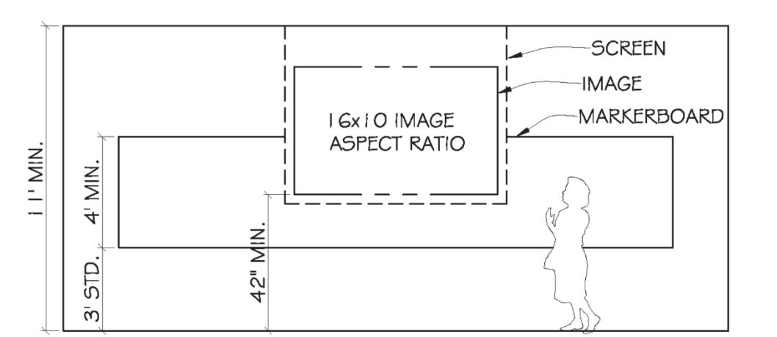
This diagram depicts the plan view of a flat classroom screen, illustrating the optimal screen height for viewing. The top of the screen must be a minimum of 11 feet from the ground. The projected image must be within the screen. The bottom of the projected image must be at least 42 inches from the ground. The center of the projected image must be at least 4 feet from the ground. The image aspect ratio must be 16X10 feet. The standard distance from the bottom of classroom markerboards to the ground is 3 feet.

FIGURE 2: FLAT-FLOOR ROOM SECTION WITH STANDARD MEASUREMENTS
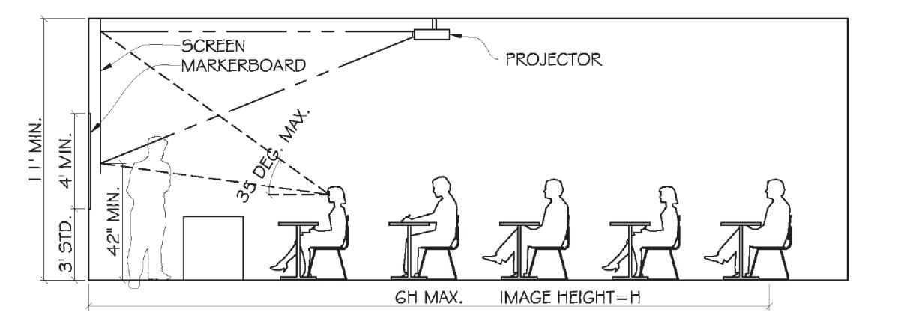
This diagram depicts the plan view of a flat classroom's optimal projector position in relation to the viewing angle of the person closest to the projection screen. The top of the screen must be a minimum of 11 feet from the ground. The bottom of the projected image must be at least 42 inches from the ground. The center of the projected image must be at least 4 feet from the ground. The standard distance from the bottom of classroom markerboards to the ground is 3 feet. The viewing angle for the person closest to the screen, as determined by the angle between the top of the screen and the bottom of the projected image, cannot exceed 35 degrees. The image height cannot exceed 6 feet.

FIGURE 3: TIERED-FLOOR ROOM SECTION WITH RETRACTABLE SCREEN,
WITH STANDARD MEASUREMENTS
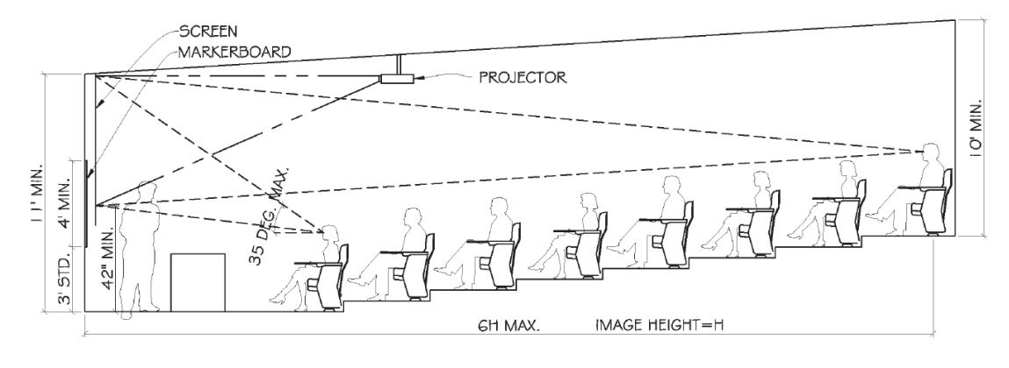
This diagram depicts the plan view tiered classroom with a retractable screen’s optimal projector position in relation to the viewing angle of the closest and furthest person in the room. The top of the screen must be a minimum of 11 feet from the ground. There must be a minimum of 10 feet between the ground under the person furthest from the screen and the ceiling above them. The bottom of the projected image must be at least 42 inches from the ground. The center of the projected image must be at least 4 feet from the ground. The standard distance from the bottom of classroom markerboards to the ground is 3 feet. The viewing angle for the person closest to the screen, as determined by the angle between the top of the screen and the bottom of the projected image, cannot exceed 35 degrees. The top of the projected image should be at the top of the screen, and the bottom should be 42 inches from the ground. The image height cannot exceed 6 feet.

FIGURE 4: TIERED-FLOOR ROOM SECTION WITH WALL PROJECTION,
WITH STANDARD MEASUREMENTS
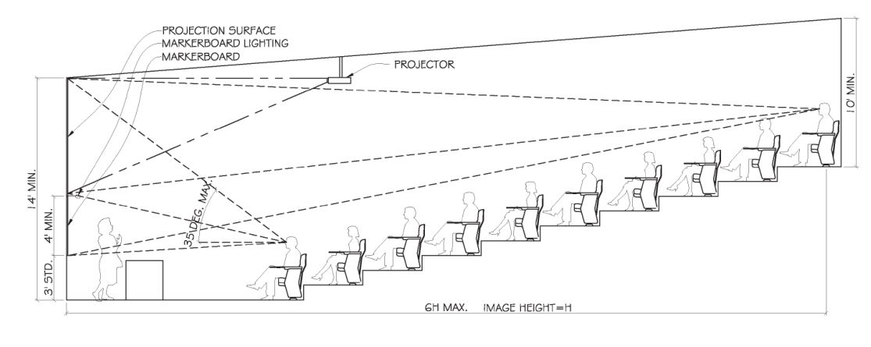
This diagram depicts a plan view of a tiered auditorium with the optimal projector position in relation to the viewing angle of the closest and furthest person in the room. The top of the screen must be a minimum of 14 feet from the ground. There must be a minimum of 10 feet between the ground under the person furthest from the screen and the ceiling above them. There must be a minimum of 4 feet between the top of the markerboard and the bottom of the projected image. The standard distance from the bottom of classroom markerboards to the ground is 3 feet. The viewing angle for the person closest to the screen, as determined by the angle between the top of the screen and the bottom of the projected image, cannot exceed 35 degrees. The top of the projected image should be at the top of the screen, and the bottom should be at least 7 feet from the ground. The image height cannot exceed 6 feet.

9.6 DISPLAY DEVICES

9.6.1 MULTIMEDIA PROJECTORS
WXGA Laser Projectors, with a minimum output of 5,000 lumens, are recommended for minimal maintenance. The number of lumens recommended will vary according to the space. The minimum resolution is 1920x1200 with an aspect ratio of 16:10. Ultra-short throw projectors may have a lower resolution of 1280x800. Any display fixed to an ultra-short throw must have the same aspect ratio. At each projector location, the following infrastructure is required:
• A quad AV power outlet
• Two jacks for data connection
• Wireless capabilities
• Conduit
• Ceiling box or drop plate

9.6.2 MULTIMEDIA PROJECTION CEILING MOUNT
High-quality, professional-grade multimedia projector ceiling mounts shall be used. ITSC will determine the final choice of brackets. Firmly tighten the projector mount’s adjustable settings. Security screws and other security features are required for tamper resistance. All projector ceiling brackets and mounts will be in accordance with the manufacturers’ specifications and rated to accommodate the projector's weight.

9.6.3 FLAT PANEL DISPLAYS
The minimum size for 4K flat panel commercial displays is 55 inches. Flat panel displays require at least two HDMI inputs. Size recommendations and display locations will vary according to the academic space. See the Maximum Viewing Distance section for the recommended display size for the space.

9.6.4 FLAT PANEL DISPLAY MOUNTS
Design options for flat panel display mounts include wall, ceiling, or mobile. All mounts will be of a high-quality professional-grade and installed according to the manufacturer’s specifications. The brackets must be secured to the display so they cannot be dislodged from the mount without authorization.

9.6.5 INTERACTIVE DISPLAYS
Interactive displays shall include lightweight commercial-grade designs with 4K resolution and anti-glare. Interactive touch and wireless content-sharing features are necessary for collaboration. Make and model recommendations may vary according to the space needs. See the Maximum Viewing Distance section for the recommended display size.

9.6.6 CAMPUS TV DISPLAYS
Campus TV requires premium hotel Pro: Idiom enabled TV displays or a Pro: Idiom set-top-box, which UIT can provide for a fee. Pro: Idiom is the encryption used for the service and is required. Pro: Idiom displays are available from LG and Samsung. A wired network connection is required for this service.

9.6.7 DIGITAL SIGNAGE

9.6.7.1 Network Connectivity for Digital Signage
All campus digital signage hardware must have network connectivity (wired preferred) for integration with the UH Emergency Notification System.

9.6.7.2 Display Considerations for Digital Signage
Viewing distance is important when determining the type and size of content to display on a digital sign. For maximum usefulness, signage in open, high-traffic areas will require different content than displays in smaller, enclosed locations. The viewing distance can be considered in three increments: Optimal, Marginal, and Visible.
Calculate monitor size using Optimal view:
(Distance from monitor to viewer divided by three equals the diagonal monitor size)
- Optimal: The distance where the audience can observe the content without losing detail.
- Marginal: The distance where the audience can see the content without detail.
- Visible: The distance where the audience can recognize general themes and information presented in the largest formats. Content is targeted to draw the audience into the Optimal range to provide more information.

FIGURE 5: VIEWING DISTANCES FOR DIGITAL SIGNAGE

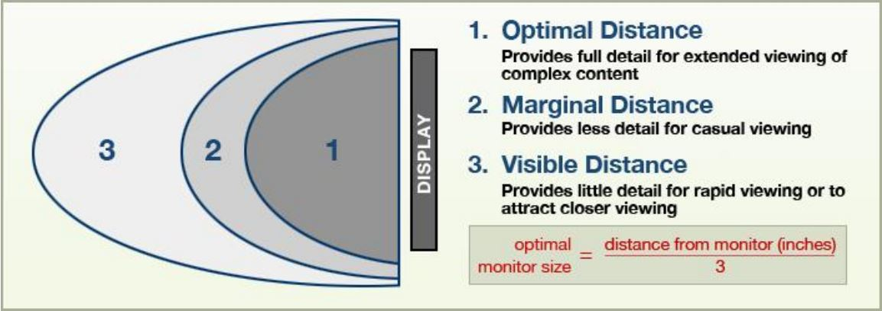
This is a chart that depicts various viewing distances for displays and a formula to determine the use case. 1. The Optimal Distance is closest to the display and provides full detail for extended viewing of complex content. 2. The Marginal Distance provides less detail for casual viewing and falls between the Optimal Distance and the Visible Distance. 3. The Visible Distance is the furthest from the screen and provides little detail for rapid viewing or to attract closer viewing. The optimal monitor size equals the distance from the monitor in inches divided by 3.

9.6.7.3 Digital Signage in Non-Classroom Spaces
- Computer hardware for digital signage in non-classroom spaces must meet the following specifications:
- Nuc computer with OS (Operating System) that supports Rise Player software
- Minimum 120 GB solid-state drive storage
- Minimum 4 GB RAM
- Screen size will vary depending on the installation location
- Multi-screen installations (video wall) should have thin bezels to look seamless between displays

9.6.8 MAXIMUM VIEWING DISTANCE FOR DISPLAYS
Several formulas are used to determine screen size. However, in a conference room, the most critical are text viewing distance and the maximum distance where a viewer can see that text.
D = (Hs x 150 x Ptxt ) / Pimg
Where
- D = Distance to farthest Viewer
- Hs = Minimum recommended screen height
- 150 = The recommended maximum distance for comfortable viewing the text (150 times the text height).
- Ptxt = Height of text in pixels. Example – 11-point text will be 15-pixel height
- Pimg = Height of image in pixels (vertical resolution)

FIGURE 6: RELATIONSHIP BETWEEN SCREEN SIZE AND VIEWING DISTANCE
A depiction of a 16:9 46-inch display that outlines the relationship between screen size and viewing distance. Font size: 16ppt (this equals 22 pixels from the conversion chart). Solve for Maximum Viewing Distance (D). Since Hs = (D*Pimg)/150*Ptxt) D=(Hs*150*Ptxt)/Pimg. D=(26.2*150*22)/1080, D=86460/1080, D-80.05”, Divide by 12 to get feet = 6.67’

9.7 AV CONTROL AND SWITCHING

9.7.1 CONTROLS AND SWITCHES
Control panels must be installed in appropriate locations within the room, ensuring easy accessibility within the environment. Switches may be installed in the AV equipment racks. The make/model recommendation will be determined during the designing phase.

9.8 AUDIO AND VIDEO

9.8.1 AUDIO
Most spaces require audio capabilities from a PC, laptop, DVD, or other source. Larger spaces will require voice reinforcement. Academic spaces, like auditoriums, require special acoustic expertise to provide effective audio systems.
Speech reinforcement systems require special attention and independent design for each space. Typically, a system capable of program playback and speech reinforcement will consist of suitable front-of-house, low-impedance speakers supplemented with delay flush-mounted ceiling speakers suitably positioned throughout the space.
Wall-mounted speaker brackets are allowed for speaker adjustments and to lock the position physically. Similarly, securely mount ceiling speakers to ceilings and provide additional support.
The number and style of microphones (hard-wired or wireless), audio processing/mixers including digital sound processors (DSP), and amplifiers will vary according to the space.
Individually specify all products for each space during the design consultation process.

9.8.2 VIDEO
Video sources will include HDMI. USB-C and Mini Display Port connectors are allowed where possible. Only use VGA when the source equipment does not support the HDMI standard. A converter to HDMI may be used in special situations.

9.9 SOURCE EQUIPMENT
The simplest spaces may provide a single connection point to a source device (e.g., a laptop). Most spaces provide a switching and control system and a selection of source devices to present material. Determine the choice of source devices in conjunction with the user group depending on the type of material presented in the space.

9.10 VIDEO CONFERENCING
The following technologies are the standard video conferencing solutions for the spaces within the University: 1. Microsoft Teams. 2. Cisco Webex. These design requirements are based on the unique technical aspects of video conferencing. Each video conferencing system must include the following core components:
- Display
- Camera (USB – 1080p or higher)
- Audio (USB or Converted to USB or built into the camera or microphones)
- Microphone (USB or Converted to USB or built into the camera or audio speakers)
- PC (i7 or higher, 16 GB RAM recommended) with wireless/Bluetooth keyboard and mouse
- Wireless/Wired Network Additional considerations to ensure a positive video conference experience include the type of video conferencing system, display size, camera position, furniture design, color selections, room size, signage, controls, etc.

9.11 LIGHTING
Different activities in a teaching space require varying lighting conditions. It is essential that the light sources used can be switched on, off, or dimmed quickly. Lighting that requires extensive delays between extinguishment and re-strike or fixtures that take more than 10 seconds to achieve maximum brightness are unsuitable for academic spaces.
To achieve low levels of ambient light spill onto projection surfaces, select light fixtures of a glare-free design with direct-light distribution only (no upward, incident light) with reflectors with cut-off or shielding angles in the direction of the screen(s). Recessed lights with non-reflective louvers and suspended lights with sufficient side-shielding reflectors and non-reflective louvers are usually suitable. Task lights and spotlights that are not turned off during projection must also have either internal cutters or external barn doors to enable illumination of people near the screen while preventing direct light from falling on the screen.
Carefully position house lights, stage lights, and lectern spotlights near the projection screens to avoid spilling on the screen. Carefully consider spotlight placement so that the spotlight's body does not impede a projector’s beam. The vertical positioning of stage lights and lectern spotlights is often a difficult balance between sufficient light on the presenter’s face and glare in their eyes. A commonly agreed balance is to position these lights between approximately 45 degrees and 60 degrees above horizontal from the presenter’s eye line.
If employing an AV control system in a space, expect lighting control to be an integrated part. Determine the exact lighting designs during the design process.

9.12 LECTURE CAPTURE
Any implementation of lecture-capture systems must conform with existing ATO and UIT systems. Any installed systems should be fully compatible with existing content management systems and other back-end systems. Lecture capture systems should be PC-based to allow the use of Microsoft Teams and Zoom videoconferencing platforms. This is an area where significant consultation with ATO & UIT personnel is required.
Careful consideration must also be given to recurring licensing fees to ensure the proposed systems fit into the department’s funding model.
Determine lecture capture equipment during the design consultation process.

9.13 EXTERNAL AV INPUT PLATES
Provide suitable AV input plates as specified by ITSC. With advance approval from ITSC, the Contractor may supply an alternative manufactured version of this plate type. All specified input types on the plate must be engraved in text.

9.14 ELECTRICAL
All installed AV equipment will require the incorporation of dedicated circuits and receptacles into the electrical design. It is unacceptable for electrical cables to be run along walls or across the floor where students, faculty, or staff walk. AV equipment will need dedicated outlets in proximity — inside cabinetry, high on walls for monitors or loudspeakers, and outside the ceiling for projectors.
It is best practice to put all equipment in a single space on the same electrical phase. This helps to eliminate electrical differences that can produce noise in audio or video systems. Enough convenience outlets should be installed, particularly in the front and back of academic spaces for portable equipment.
Provide outlets adjacent to projector mounts, monitor mounts, electric screens, and any other powered equipment, such as amplified loudspeakers or infrared assistive listening emitters. Outlets should be mounted within the ceiling space or recessed to be unobtrusive. The best practice for monitors and projectors is to provide dual outlets for ancillary equipment.

10.0 NETWORK INFRASTRUCTURE COMPONENTS AND SECURITY

10.1 REQUIREMENTS
As AV systems are designed and planned, it is important to ensure that they comply with the Montana State University UIT Network Infrastructure Design Standards.
When designing AV systems, consider security concerns. Unauthorized access to AV devices, for malicious intent or otherwise, can wreak havoc on a system and cause unnecessary interruptions in campus operations. Device registration will be necessary. All devices will have the latest available firmware installed at the time of deployment. Document each installed device's serial number and MAC address.

11.0 AUDIOVISUAL CABLING INSTALLATIONS
Refer to UIT Network Infrastructure Design Standards for details.

12.0 ADA COMPLIANCE AND INTEGRATION

12.1 HEARING AUGMENTATION
The audiovisual integrator must supply and install an under-floor induction loop with a low spill design to ensure no audio is audible in adjacent spaces. Where there is a danger of spilling into adjacent rooms, above or below, provide an ultra-low spill, phased array loop. When an under-floor solution is not possible, install an FM or IR solution.
The supply and installation of any hearing augmentation system into a teaching space is to comply strictly with the following:
- 2010 ADA Standards for Accessible Design
- Infrared receivers with a minimum of 95% coverage
- One IR receiver for every 25 persons up to 500 persons
- Test results that the installed system meets or exceeds the current standards for audit purposes.

12.2 MOUNTING HEIGHTS FOR VISUALLY INTERACTIVE DEVICES
A height of 54 inches is acceptable if the device is side-approachable. Otherwise, a maximum height of 48 inches applies to access controls, peripherals, and ports.

13.0 SYSTEM PROGRAMMING

13.1 EXTRON
Extron systems are highly recommended for handling any programming and configuration needs to facilitate collaboration, empower learning, and enhance communication and workflow. Provide specific recommendations for each learning space according to the user's needs.

14.0 AUDIOVISUAL (AV) SYSTEM INSTALLATION PROCESS

14.1 GENERAL GUIDELINES
The audiovisual integrator will install the AV equipment as outlined throughout the specified scope of work. Complete all work to a high standard, and the product will be a fully functioning audiovisual system.
- In accordance with AV industry best practices, all mounting hardware will be at minimum Grade 5 hardware. All load calculations will use a minimum 5x safety factor so that each fastener can carry the object's load and the redundant anchors. Where appropriate, utilize fasteners that are rated for overhead use. Before installation, the project structural engineer shall approve specification sheets for all anchors.
- Install all plates, controller, screen, duct or conduit, speaker brackets, projector bracket, and wall equipment cabinet so they are square, flush, and level. The mounting screws/washers/bolts used to fix a specific item are all to be at minimum Grade 5 or better and match that specific item type.
- UIT Network Services will supply most or all network connections. Refer to UIT Network Infrastructure Design Standards for networking guidelines.
- Audio will be free of buzz, hum, or other undesired noise. Base the exact speaker positions on a practical determination of the best sound coverage. Key decision factors include room layout, sound obstructions, and dispersion properties of speakers.
- Projection devices will be free of any hum bars, shimmer, flicker, ghosting, or any other undesired artifacts, up to the native input resolution of the projection device.
- All ceiling and wall cuts are to be neatly made and positioned to meet the needs of the space.
- In consultation with UIT, provide adequate power. All electrical work must be provided by a licensed electrician and completed according to relevant US Standards. Determine the final number of power outlets during the design consultation process.
- Provide documentation for all installed devices. Include manuals, diagrams, support, and end-user’s documentation.
- Ensure nothing blocks the projector display, including lights, speakers, etc.
- All AV cabling must follow MSU-UIT cabling specifications for routing, support, etc.

14.2 PROJECT RESPONSIBILITIES BY PHASE
Planning and Programming
• Needs analysis
• Physical or virtual benchmarking
• Literature search
• Existing campus plans analysis
• Research on emerging technologies and pedagogies
• User interviews
• Narrative descriptions of the various spaces and systems
• Budgeting
AV and IT infrastructure
• Room geometry, layouts, sightlines, and adjacencies
• Cable pathways and technical requirements
• Architectural integration and aesthetic requirements
• Coordination with other design disciplines
AV and IT systems
• Conceptual design and budgeting
• Detailed design and budgeting specification
• Supply
• Installation design and specification
AV and IT integration planning
• Network security
• IP addressing and network layout
• Physical location of equipment
Lecterns, operator consoles, and other furnishings
• Design and/or selection
• Supply
• Installation and modification

Control systems
• Layout of user interface
• GUI flow and user needs
• Programming, installation, testing and debugging
• Training
Construction administration
• Shop drawings
• Submittal reviews
• Infrastructure reviews
• Coordination, scheduling, and planning
• Final checklist and acceptance testing
Installation
• Definition by specific system
• Cable pulling and labeling
• Physical installation
• Configuration, tuning, and optimization
• Testing and troubleshooting schedule
• Coordination with other trades
Training
• End-user training
• Support staff training
• Training documentation
Service and maintenance
• Instruction for placing service calls
• Maintenance plan and proposed schedule

15.0 RECOMMENDED HARDWARE LIST

15.1 EQUIPMENT MAKE AND MODEL
EQUIMPMENT TYPE | PREFERRED MAKE AND/OR MODEL
Touch Screens | Newline, Dell
Projectors | Epson
Commercial displays | NEC/Sharp, Newline
Pro: Idiom Displays | Samsung, LG
Projector Mounts | Chief
Display Mounts | Chief
AV Switchers | Extron
AV Controllers | Extron
Computers | Dell, Microsoft, Intel NUC, IBM
Amplifiers | Extron, Biamp, Community
Microphones | Shure, Biamp, Revolabs, MXL
Speakers | Extron, Community, JBL
Hearing Assistance | Listen Tech
Source Devices | HDMI, USB-C, Casting
Power Conditioner | Furman, Middle Atlantic
Networks Devices | RJ45
Video Cameras | Logitech, Vaddio, Biamp, Marshal, basic webcam
Lecterns | Spectrum, VFI
Cabling | CommScope, Extron

